MACH4METAL

metalworking machinery
Transito 21, 6909 DA Babberich, Netherlands
Tel. + 31 (0)316 – 247123
Fax. + 31 (0)316 - 247956
info@mach4metal.com
www.mach4metal.com
Bank No : 66.52.13.883
IBAN : NL33 INGB 0665 2138 83
BIC : INGBNL2A
VAT : NL 815393635B01

HEGENSCHEIDT Rail – Way Lathe

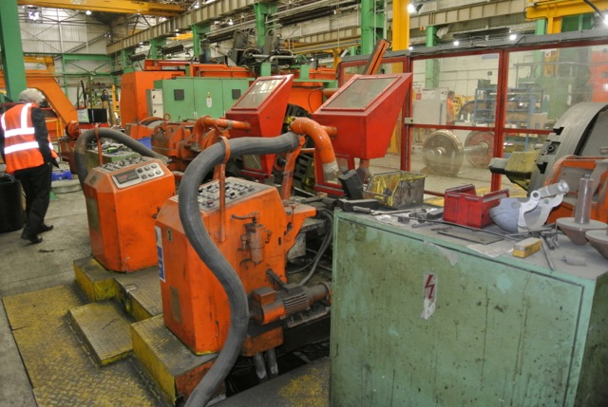
- Make : Hegenscheidt Germany
- Typ : 167 L
- Age : 1984
- Mach.No. s/n100 762

- Height of center : 800
- Rail track gauge : 1.435
- Max. wheel tread Ø. : 1.372
- Min. wheel tread Ø. : 621
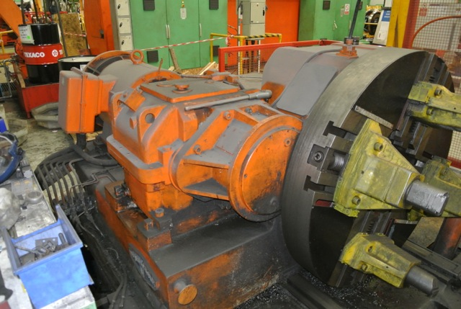
- Max. axle length wheel set: 2.440
- Min. axle length wheel set: 1.642

- Face plate Ø. : 1.334
- Ø headstock quills : 220
- Stroke quill : 500
- Face plate speed : 27 Rpm
- Cutting speed Ø 1000 : 85 m/Min

- Dimensions
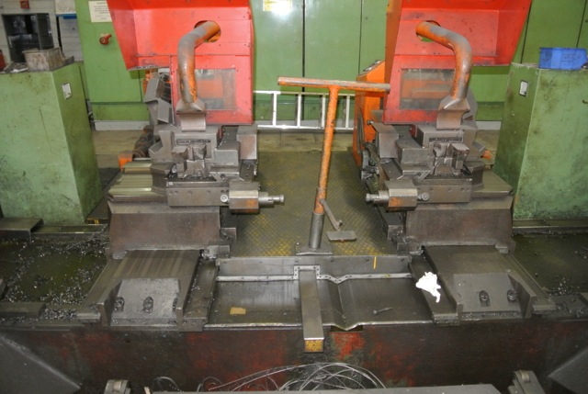
- Length : 9.120
- Width : 3.000
- Height : 3.000
- Weight : 43.000 kg / 2 x 42 kW

- Hegomatic copying slide for re profiling
- Measuring arm
- Two lateral & diameter positioning device

The machine is semi automatic, high-performance and suitable for the machining the profiles and faces of new and worn tyres of locomotive, wheel sets ,carriage and wagon wheel sets, diesel railcar, passenger carriages, goods wagons and multiple unit electric wheel sets.

Please Note: The above information has been obtained to the best of our ability and belief from, and from the manufacturers where possible. It is given in good faith, but its accuracy can not be guaranteed. Accordingly, it will not form a representation or constitute contractual terms. We advise you to check any vital details!

